**NOISE POLLUTION MONITORING**

**ABSTRACT**

Noise pollution is an increasingly prevalent issue in urban environments, leading to adverse health effects and decreased quality of life for residents. To address this problem, a Noise Pollution Monitoring System (NPMS) has been developed. The NPMS is an integrated platform that combines real-time noise data collection, analysis, and reporting. It utilizes an array of strategically placed sensors to continuously monitor noise levels across different locations in urban areas.

The NPMS collects noise data, processes it, and provides valuable insights into noise patterns, sources, and potential hotspots. Advanced data analytics and machine learning algorithms are employed to differentiate between various noise sources, such as traffic, industrial operations, construction activities, and social events, enabling authorities to take targeted actions for noise reduction and control.

**INTRODUCTION**

Noise pollution monitoring is a crucial practice aimed at assessing and controlling excessive and harmful levels of noise in our environment. It involves the systematic measurement, analysis, and management of noise to safeguard public health and well-being. By employing various tools and technologies, such as sound level meters and environmental noise monitoring systems, noise pollution monitoring helps authorities, organizations, and individuals understand the extent of noise pollution, identify its sources, and develop strategies to mitigate its adverse effects. This process plays a pivotal role in urban planning, regulatory compliance, and the preservation of peaceful and healthy living environments.

**DESIGN**

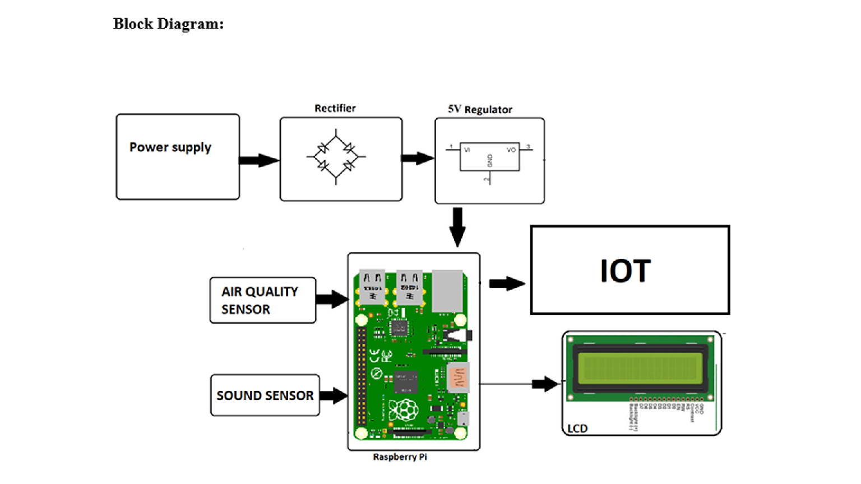

**HARDWARE COMPONENTS**

**\*** Raspberry pi

**\*** Sound sensor

**\*** Optical dust sensor

**\*** Esp8266 wifi module

**\*** MQ6 gas sensor

**\*** 16×2 LCD display

**\*** Power supply

**\*** Buzzer

**1.Rasberry pi**

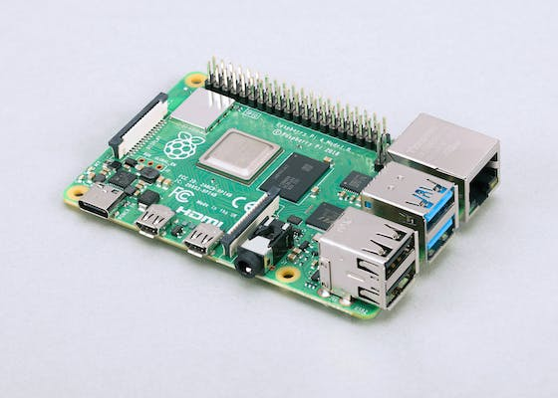

The Raspberry Pi is a small, affordable single-board computer developed by the Raspberry Pi Foundation. It was created to promote computer science education and provide a low-cost platform for various projects. Raspberry Pi computers come in different models, with various capabilities, but they all typically include a CPU, RAM, USB ports, GPIO pins for hardwareinterfacing, HDMIoutput for displays, and support for various operating systems. They're used for a wide range of applications, from learning programming to building DIY electronics and home automation systems.

**2.Sound sensor**

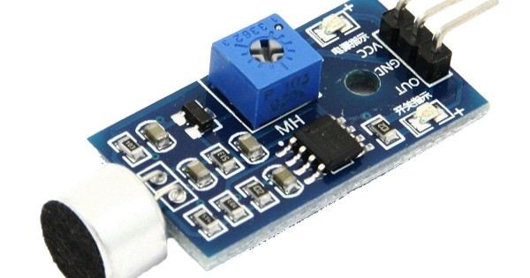

A sound sensor, also known as a sound detector or sound sensor module, is an electronic component that can detect sound waves and convert them into electrical signals. These sensors typically use a microphone or a specialized transducer to capture sound, and then they produce an analog or digital output that corresponds to the sound's intensity or frequency. Sound sensors are commonly used in applications like noise monitoring, voice recognition, security systems, and in various projects that involve audio detection and analysis.

**3.Optical dust sensor**

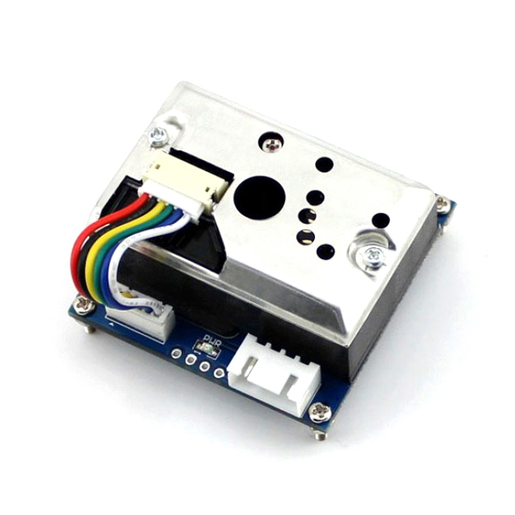

An optical dust sensor is a device that uses light-based technology to detect and measure the concentration of dust particles in the air. It typically works by emitting light, often laser or LED light, into the air and then measuring the scattering or absorption of that light caused by the presence of dust particles. This data can be used to estimate the level of air pollution or dust in an environment, and such sensors are commonly used in air quality monitoring systems, HVAC systems, and industrial settings to ensure clean and safe air.

**4.Esp8266 wifi module**

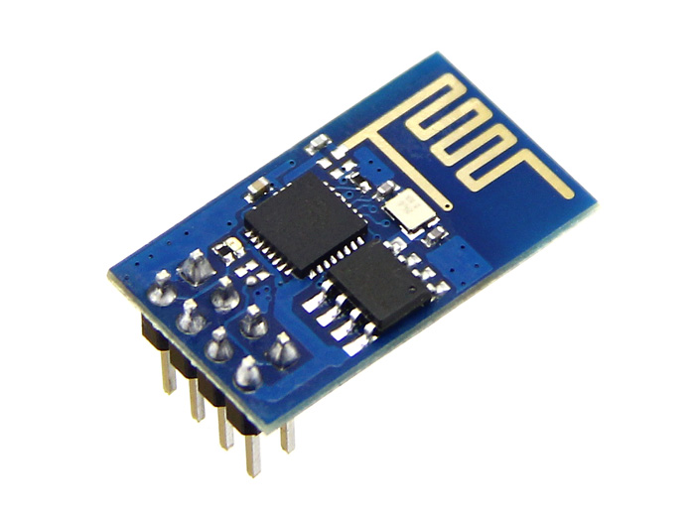

The ESP8266 is a popular Wi-Fi module, also known as a microcontroller, developed by Espressif Systems. It is widely used in the field of Internet of Things (IoT) and embedded systems. The ESP8266 module provides both Wi-Fi connectivity and the ability to run simple programs, making it suitable for a variety of applications. It's known for its low cost, low power consumption, and ease of use, and it can be programmed using the Arduino IDE or other development platforms. The ESP8266 is commonly used for building IoT devices, home automation projects, and more.

**5.MQ6 Gas sensor**

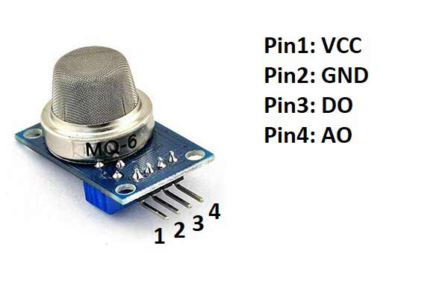

The MQ-6 is a type of gas sensor. It is designed to detect and measure the concentration of various gases in the air, such as LPG (liquefied petroleum gas), butane, propane, and methane. These sensors are commonly used in applications like gas leak detection in homes and industrial settings, as well as in gas detection systems for safety and environmental monitoring. The MQ-6 gas sensor operates on the principle of electrical resistance changes in response to the presence of specific gases.

**TECHNICAL STACK**

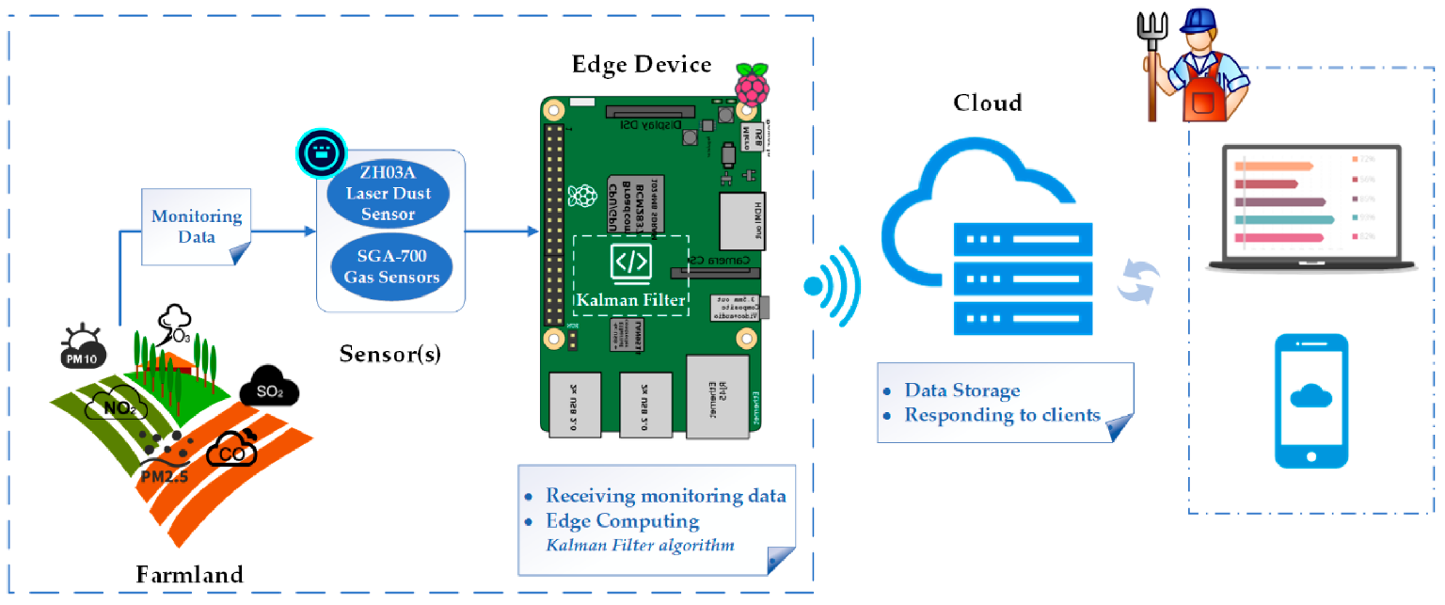

**CONCLUSION**

In conclusion, noise pollution is a pressing environmental issue with far-reaching impacts on human health, well-being, and the environment. It disrupts our daily lives, contributes to various health problems, and disturbsecosystems**.** Addressing noise pollution requires a combination of effective regulations, responsible urban planning, and individual efforts to reduce noise at its source. By taking action to mitigate noise pollution, we can create quieter, more peaceful communities and safeguard our health and the environment for future generations.

**THANK YOU**